Manual Testing Bug Report –
Application: Holland & Barrett Website
Prepared By: Binit Kumar Singh
Date: 01/07/2026
Objective -This document contains the bugs identified during manual testing of the Holland & Barrett website.
The objective is to document functional and usability issues with clear reproduction steps, expected results, actual results, severity and priority.

Bug Report - Holland & Barrett Website
BUG-01: Cart not updating correctly:

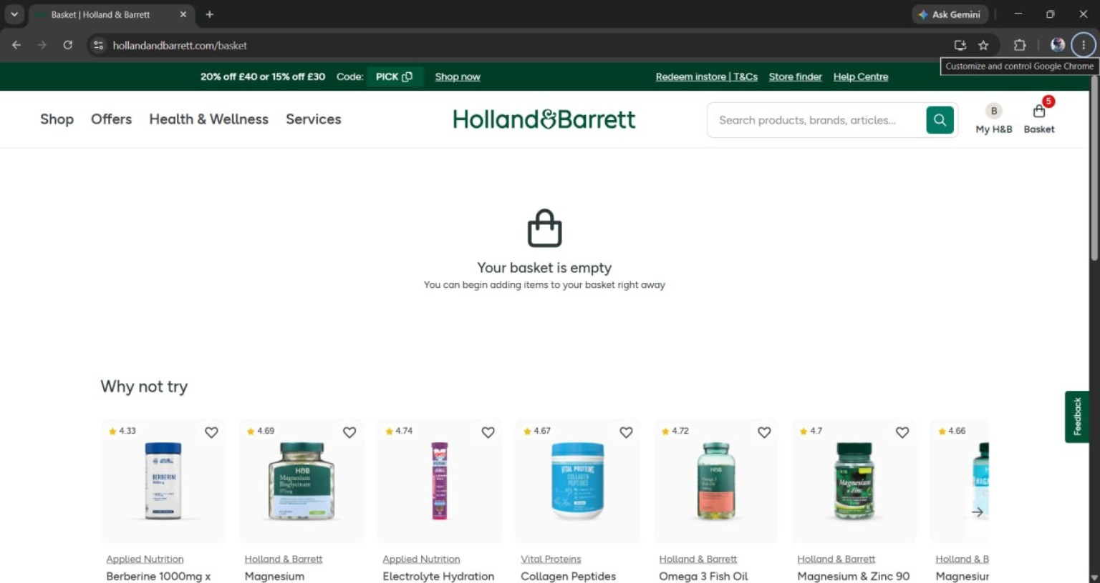
Module: Cart
Issue: Basket count/state is inconsistent after adding items.
Expected: Basket count, items and total update immediately.
Actual: Basket state is inconsistent.
BUG-02: Coupon validation missing
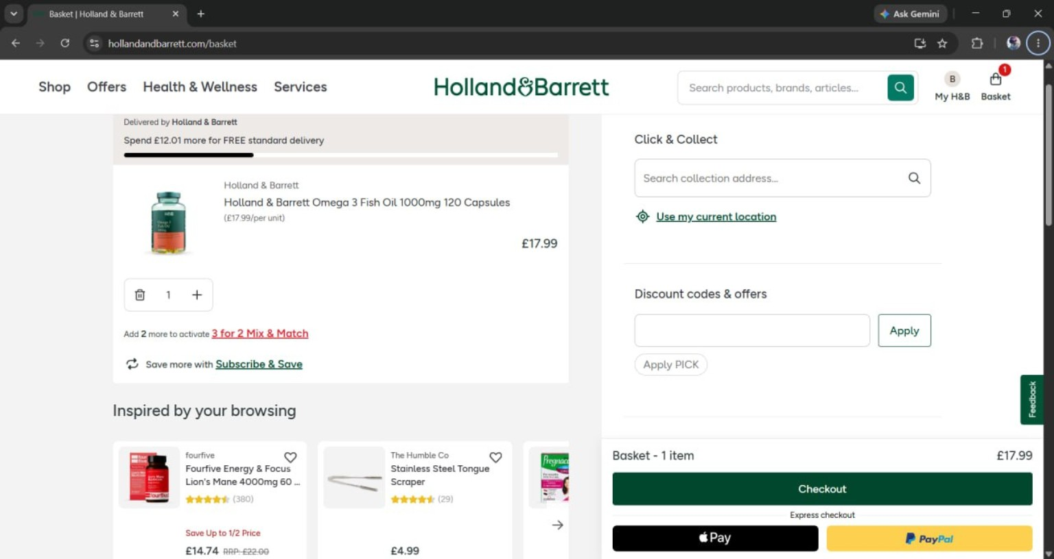
Module: Checkout
Issue: Clicking Apply with an empty coupon field shows no validation.
Expected: Display 'Please enter a coupon code.'
Actual: No validation is shown.

BUG-03: Console Errors
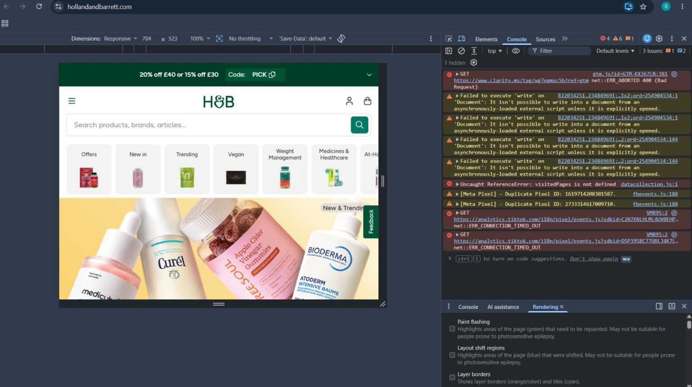
- Console Message:
Uncaught ReferenceError: visitedPages is not defined. The JavaScript code is trying to access the variable visitedPages before it has been declared or initialized, causing the script to fail.

BUG-04: My Account page not working
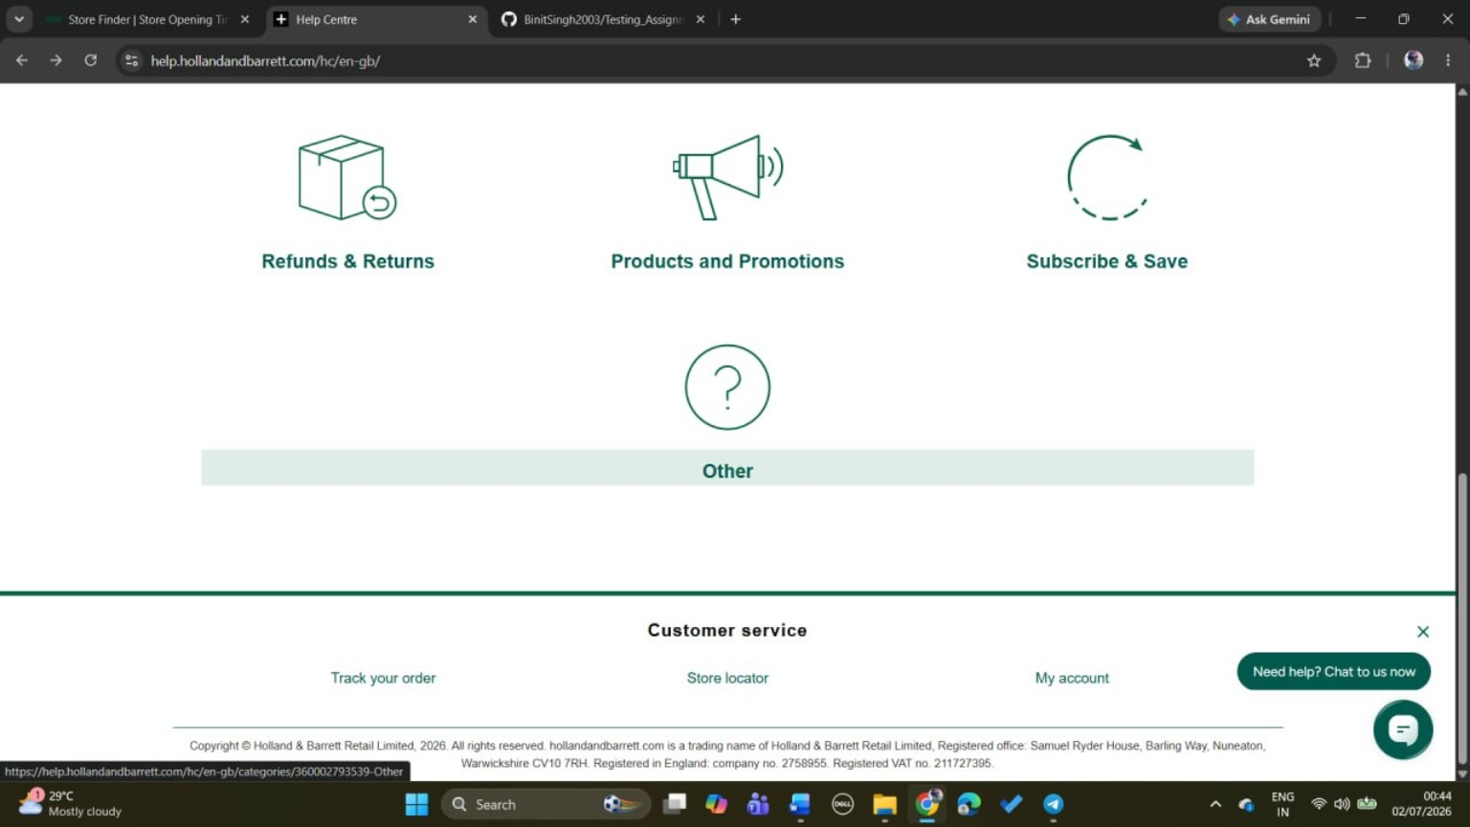
Module: My Account
Issue: Page opens a Page Not Found (404).
Expected: Redirect to My Account/Login page.
Actual: 404/Page Not Found.

BUG-05: Console Error

Console Message:
GET https://analytics.tiktok.com/i18n/pixel/events.js
net::ERR_CONNECTION_TIMED_OUT.
Description: The browser is unable to load the TikTok Analytics script because the network request timed out. As a result, analytics tracking may not work correctly

